**Retrying When Error Occurs:**

Let get the code to try again!!

Move code out of ngOnInit() method and replace with the method loadData()

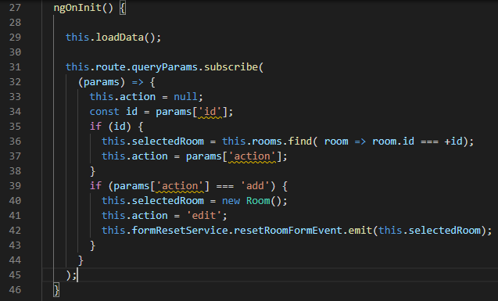

The loadData() method contains

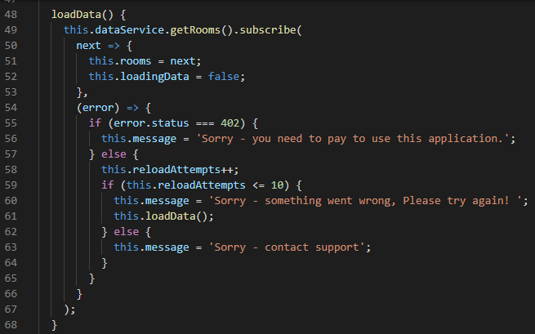

The reloadAttempts is to avoid a stack Overflow error

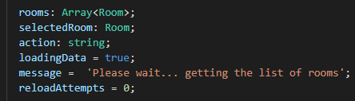

Retry the application with the server stopped

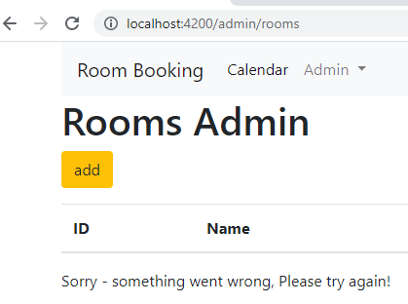

This automatically happens 9 times and the message changes!!

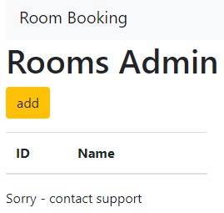

**Surviving a page refresh:**

Create a method call processUrlParams()

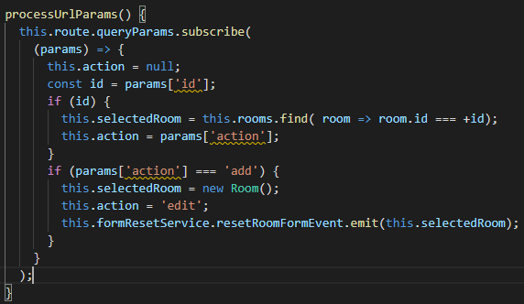

Move the call processUrlParams() from ngOnInit() to the loadData() method

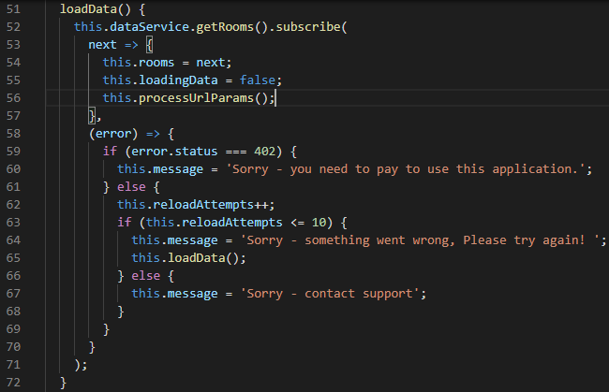

This should make sure the data is available on the REFRESH

